

Deployment Note

for

Product Item Module

Myanmar Software Engineer Contest 2020

Team Name: Charmers Tech

Date: 9/11/2020

Version: Final Version

Content

Option 1

1. Overview

2. Software Installation Steps

3. Getting Project Folder

4. Database Configuration

5. Testing the installation

6. References

Option 2

This application can be tested via following link,

<https://itemmodule.herokuapp.com/SE2020/App/>

**1.Overview**

Apache web server (Version: 2.4.46), MySQL (Version:15.1) and PHP (Version :7.4.11) are needed to run this “Product Item Module” application. In this place, all of the above requirements are included in XAMPP(Version:3.2.4) application. So, we will install XAMPP(Version:3.2.4) application.

**2. Software Installation Steps**

Installation of this product is supported on the following operation systems and versions:

Window 10 Pro (Version: 1903)

Window 10 Pro (Version: 2004)

**2.1 Getting Xampp (Version:3.2.4)**

You can download Xampp Installer from [apachefriends.org](https://www.apachefriends.org/download.html).

Choose PHP 7.4.11

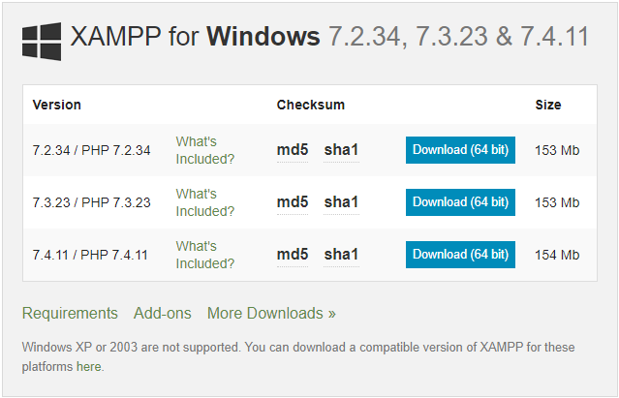

**Figure 1: Getting Xampp**

**2.2 Run .exe File**

Once the software bundle has been downloaded, you can start the installation by double clicking on the file with the ending .exe.

**2.3 Deactivate Antivirus Software**

Since an active antivirus program can negatively affect the installation process, it’s recommended to temporarily pause any antivirus software until all XAMPP components have successfully been installed.

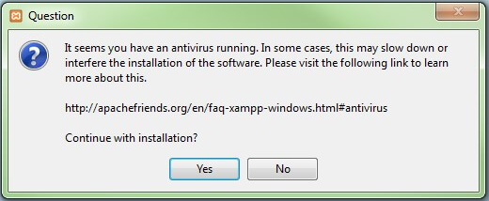

**Figure 2: Deactivate Antivirus Software**

**2.4 Deactivate UAC**

User Account Control (UAC) can interfere with the XAMPP installation because it limits writing access to the C: drive, so we recommend you deactivate this too for the duration of the installation process.

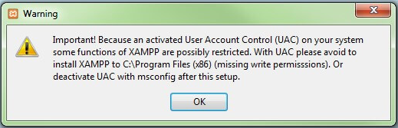

**Figure 3: Deactivate UAC**

**2.5 Start the setup wizard**

After you’ve opened the .exe file, the start screen of the XAMPP setup wizard should appear automatically. Click on ‘Next’ to configure the installation settings.

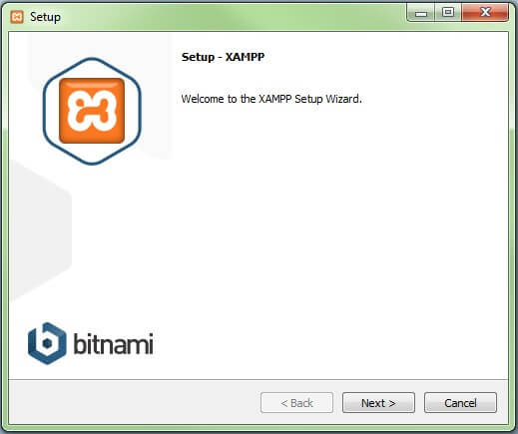

**Figure 4: Installing Xampp**

**2.6 Choose Software Components**

Under ‘Select Components’, Apache, MySQL, PHP, phpMyAdmin must be chosen. After making your choice, click ‘Next’.

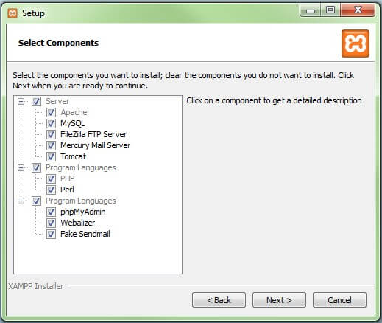

**Figure 5: Choose Software Component**

**2.7 Choose the Installation Directory**

In this next step, a folder with the name “xampp” will be created under C:\ for you. After you’ve chosen a location, click ‘Next’.

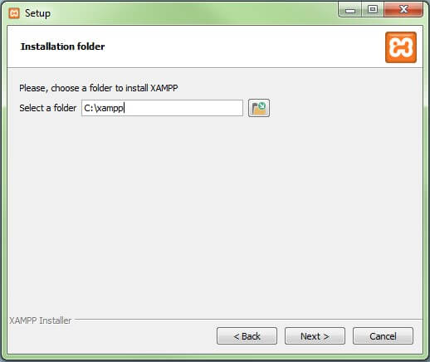

**Figure 6: Choose the Installation Directory**

**2.8 Start the Installation Process**

This process can take several minutes in total. Appear like the following figure.

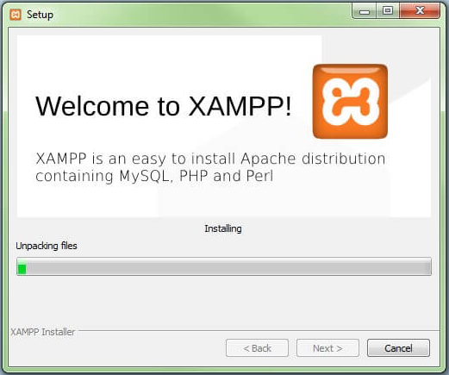

**Figure 7: Installation Process**

**2.9 Window Firewall Blocking**

Your Firewall may interrupt the installation process to block the some components of the XAMPP. Use the corresponding check box to enable communication between the Apache server and your private network or work network. Remember that making your XAMPP server available for public networks isn’t recommended.

**2.10 Complete Installation**

Once all the components are unpacked and installed, you can close the setup wizard by clicking on ‘Finish’. Click to tick the corresponding check box and open the XAMPP Control Panel once the installation process is finished.

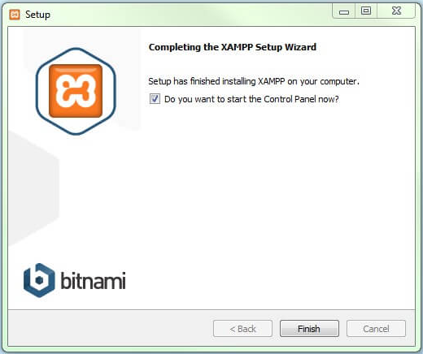

**Figure 8: Complete Installation**

**2.11 The Xampp Control Panel**

After completing installation process, Xampp Control Panel will appear like the following figure 9.

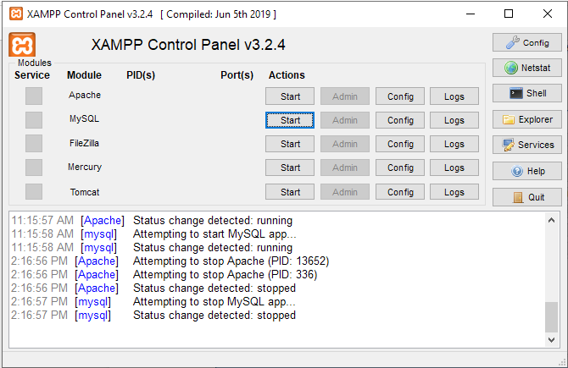

**Figure 9: XAMPP Control Panel**

If XAMPP Control Panel does not appear,

1. Start Menu >>> Xampp Control Panel

2.Right Click On >>> Click “Run as Administrator”

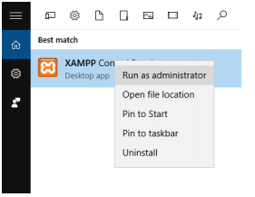

**Figure 10: Run as Administrator**

**2.12 Starting Module**

Apache and MySQL modules can be started or stopped on the XAMPP Control Panel through the corresponding buttons under ‘Actions’. You can see which modules have been started because their names are highlighted green under the ‘Module’ title.

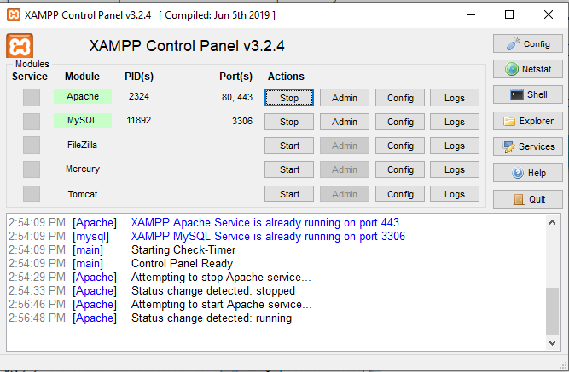

**Figure 11: Starting Module**

**2.13 Module Administration**

If Apache Web Server is running, open your favorite browser and enter “<http://localhost>” at URL bar.

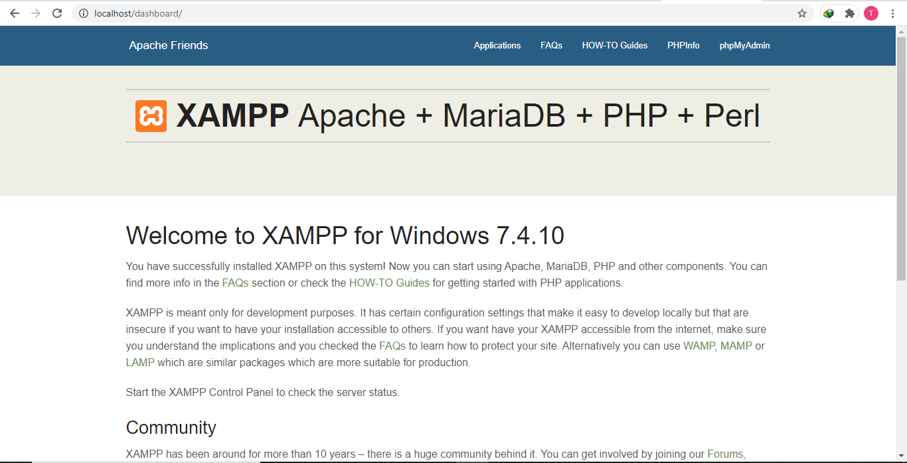

**Figure 12: XAMPP Dashboard**

**2.14 Setting Up Xampp**

A common source of error connected with Apache is **blocked ports**. If you’re using the standard setup, then XAMPP will assign the web server to main port 80 and the SSL port 443.To solve this issue,

Change the Xampp Module port setting

* Click the “Config” button >>> Apache (httpd.conf)

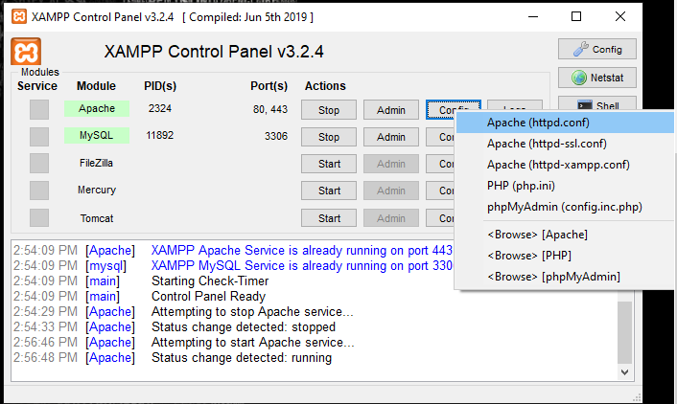

* Replace Port Number 80 to 90 at “Listen”

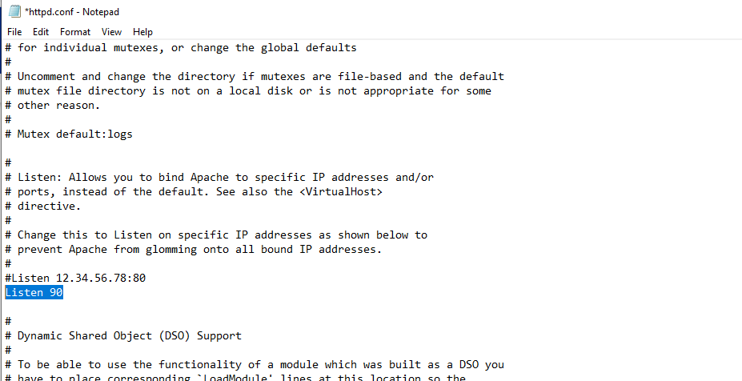

* Replace Port Number 80 to 90 at “ServerName localhost”

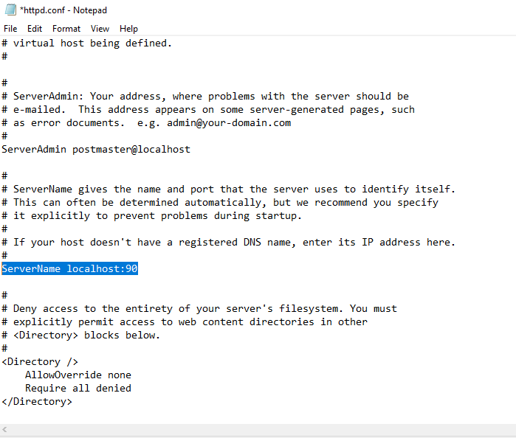

**Note: After solving above issue, repeat Section (2.12 and 2.13).**

**3. Getting Project Folder**

* To get the project folder, click the following link :

<https://github.com/Charmers-Tech/SE2020>

* Then, download the project folder.

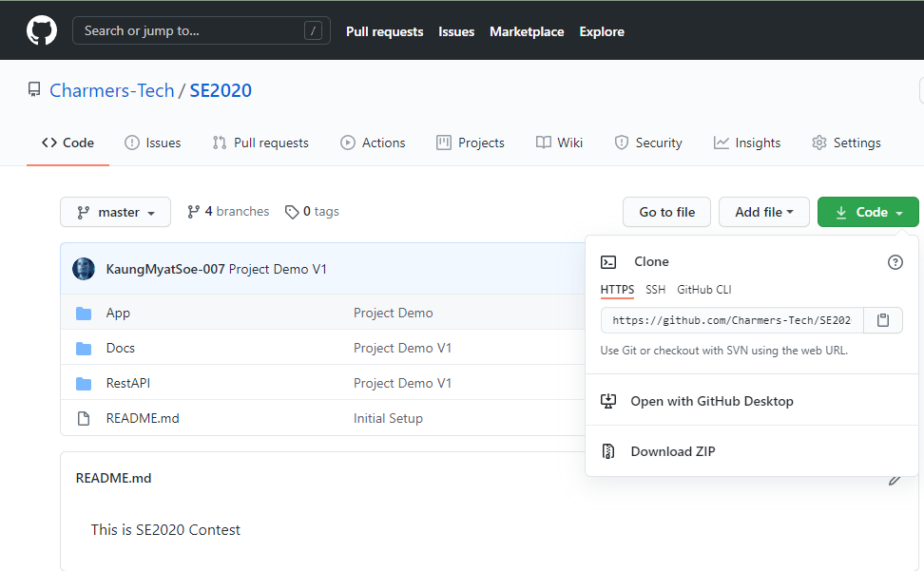

* Place and extract downloaded file (SE2020-master.exe) under “C://xampp/htdocs/” and then rename the folder name as “SE2020”.

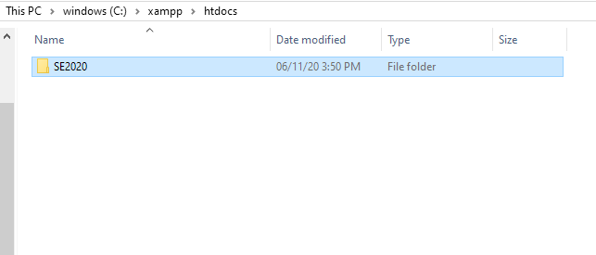

**4. Database Configuration**

* To start phpMyAdmin, open your favorite browser and enter “<http://localhost>” or “<http://localhost:90>” at URL bar.
* Click “phpMyAdmin” at Menu bar.



* To create a database,

1. Click New.
2. Database name must be “productitem” .
3. Choose “utf8_unicode_ci” >>Click Create

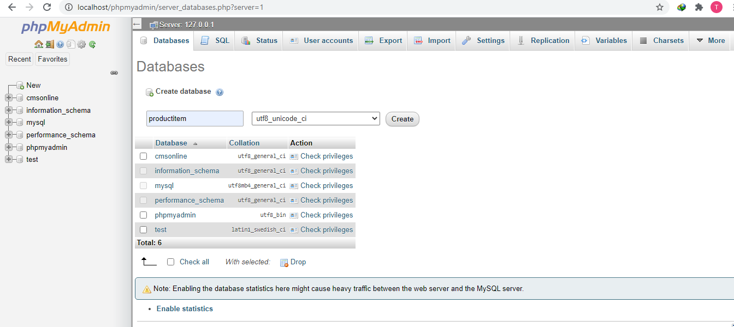

* Importing into the database “productitem”

1. Click “Import”.
2. Choose File >> “C:\xampp\htdocs\SE2020\Docs\productitem.sql”
3. Click “Go”.

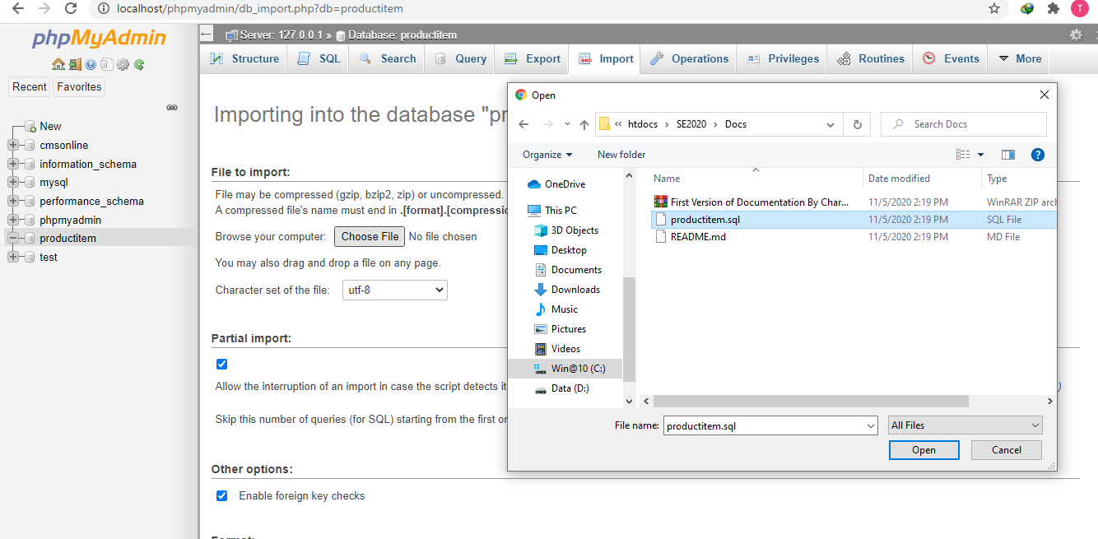

* Finishing Database Configuration

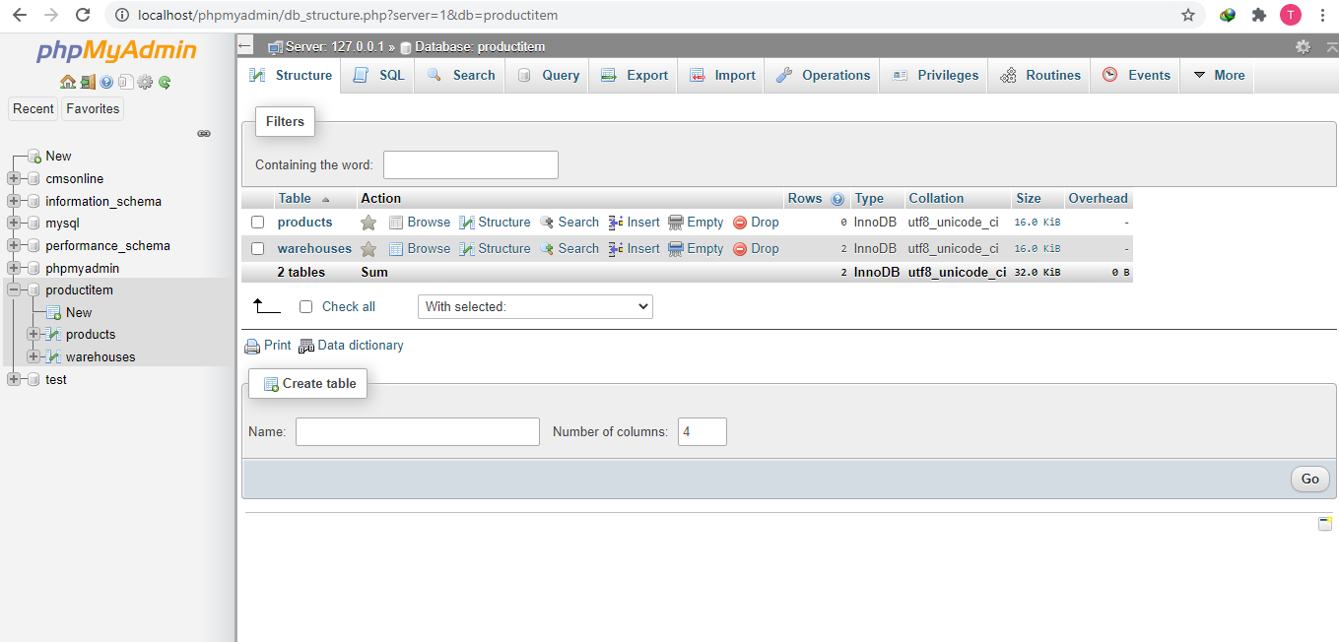

**5. Testing the installation**

To test the “Product Item Module” application, open your favorite browser and enter <http://localhost/SE2020/App/index.php> at URL bar.

**6. References**

* [**digitalguide/xampp tutorial**](https://www.ionos.com/digitalguide/server/tools/xampp-tutorial-create-your-own-local-test-server/)
* **Professional-Web-Developer-4th-Edition-by-Ei-Maung.pdf**